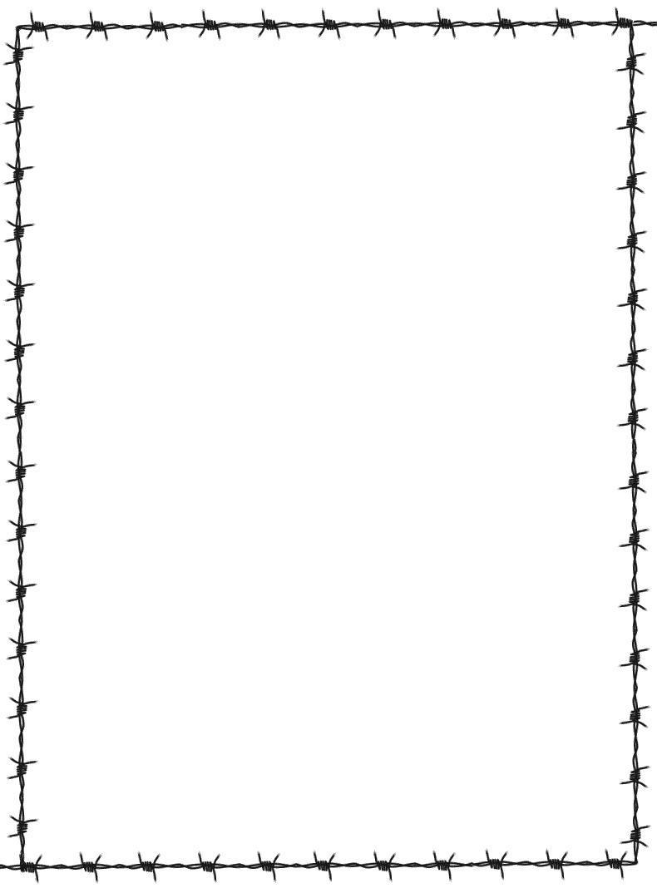Name: ­­­_________________________

Date: __________________________

Period: ­­­­­­­­­­­­­­­­­­­­­­­_________________________

**“Night” by Elie Wiesel**

**Chapter 1**

Vocabulary

|  |  |  |
| --- | --- | --- |
| Word | Page # | Synonym |
| Penury | 3 |  |
| Kabbalah | 3 |  |
| Synagogue | 3 |  |
| Indulgently | 5 |  |
| Zionism | 8 |  |
| Anti-Semitic | 9 |  |
| Ghetto | 11 |  |
| Surreptitiously | 16 |  |
| Surreal | 17 |  |
| Conflagration | 21 |  |

Questions

Answer each question with a complete sentence and provide the page number where you found the information.

1. What does Elie’s interest in the Kabbala and his devotion to his religion say about what kind of person he was?
2. Why is Moishe the Beadle’s story so important? Why do you think Elie starts his story by telling us about him?



1. What kind of person is Elie’s father? What does he do for a living? Is he important to the community?
2. What was the Jews response to reports about the war and the arrival of the Germans to their town?
3. What was the result of Elie’s father’s meeting with the council?
4. What was the response of the Jews to the Germans and the war after some were deported and others moved to the ghetto?
5. How many chances did Elie’s family have to escape? (Please provide specific examples and the page number where you find the information.)
6. Did you notice a change in mood from the beginning of the chapter to the end? Cite a specific sentence from the beginning and compare it to one at the end.